**EXERCISE 4a:**

**Conduct task analysis for an app (e.g., online shopping) and document user flows. Create corresponding wireframes using Lucidchart**

**Aim:**

To understand and document the steps a user takes to complete the main tasks within

an online shopping app.

**Procedure:**

1. **Create a New Document**

* Sign in to Lucidchart and click on "+ Document" or "Create New Diagram."

1. **Select a Template**

* Start with a blank document or choose a flowchart template.

1. **Add Shapes for Each Step**

* Drag shapes (rectangles for actions, diamonds for decisions) to represent steps like: Login/Register, Browsing, Adding Products, Cart Management, Checkout, and Tracking Orders.

1. **Connect the Shapes**

* Use connectors and arrows to show the flow from one step to the next.

1. **Add Details to Each Step**

* Double-click shapes to describe actions, like "Click Sign Up" or "Enter details."

1. **Use Different Shapes for Actions**

* Rectangles for actions, diamonds for decisions, and ovals for start/end points.

1. **Customize and Organize**

* Arrange shapes logically, use colors for clarity, and group related steps.

1. **Review and Save**

* Ensure everything is connected properly, then save by clicking File > Save.

1. **Share and Collaborate**

* Share the flowchart or export it as an image/PDF.

**Output:**

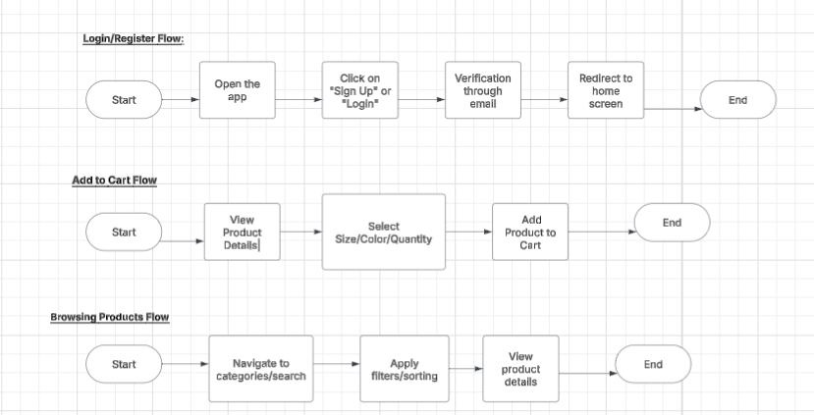

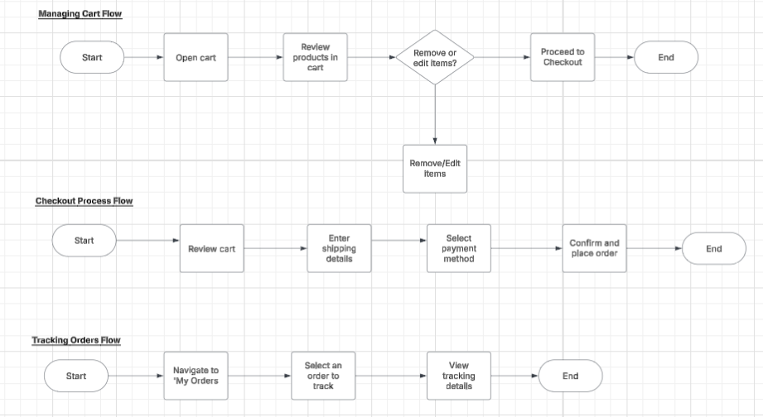

**Link:**

<https://lucid.app/lucidchart/69926ff7-a2b7-4f1c-93c9-29ca626c5496/edit?viewport_loc=-538%2C851%2C3188%2C1287%2C0_0&invitationId=inv_a9421318-8144-46c9-bc8e-7e93f0f9edb3>

**Result:**

Hence, the task analysis for an app has been successfully executed.